Parish Announcements and Events!
Do you want to know more about the Catholic FAITH? Are you Missing a Sacrament? Are you Interested in Becoming Catholic?
RCIA sessions are held on the 3rd Saturday of each month at 5pm in the Church.
Next Session will be on 21st February 2026.

Next Baptism Course for parents is in 2026 at St Vincent’s Parish with Fr Riq, Vivek and Jessica.
The date for the Baptism course evening will be Wednesday 28th January 2026 at 7.00pm here in our Parish Church.
Please email the Office for more Information Becontree@brcdt.org

Ash Wednesday this year is on 18th February 2026.
Masses will be at 9:30am and 7pm for those coming after work.
If you or someone you know is housebound or sick and unable to attend, please let us know and the ashes will be taken to you. Blessings for healing of mind, body and soul.

Friday Night at the Films
The Chosen episodes are shown every Friday at 6pm. We share a meal in between episodes. Come and join our community.

A Humble Reminder on How to Receive Holy Communion:
We are called to maintain reverence to the Most Holy Eucharist; therefore, we are kindly reminded:
• Please refrain from chewing gum prior to approaching the altar for holy communion.
• Please receive the Sacred Host with both hands or directly on the tongue; do not grasp with fingers.
• The Sacred host MUST be consumed immediately in the front before returning to your seat.
• Please approach and depart with reverence, mindful of the Real Presence of Christ in the Church.

St. Vincent’s Parish Building projects needed:
1. Boiler basement needs to be treated for black mould.
2. Front church doors need to be changed with Fire Push door opening handles.
3. Fire alarms and signs need to be placed and installed.
6. Church floors need to be professionally polished in order to extend their life span.
7. Repair of recently discovered cracks in the front of the church wall.
8. Presbytery house dining room to have a built extension outwards into a multi-use meeting room for parish use, as we don’t have a parish hall.
9. Ashes garden of remembrance needs to be revitalised and beautified.
10. The current leftover loan debt from Fr Pat Salmon’s (RIP) chapel build is at £15.000, which is the reason that we are not allowed to get any further funding for any new works.

Mrs. Helen Craft, Headteacher
St Vincent’s Primary School 02082706695
CATHOLIC PARISH OF SAINT VINCENT de PAUL
57 Waldegrave Road, Dagenham, Essex RM8 2QB
Parish Priest: Fr. Riq Fernandez Email: FrRickFernandez@brcdt.org
Tel: 020 85907222 Office Email: Becontree@brcdt.org
New Website: StVincent-Becontree.co.uk & our Facebook and YouTube Channel
Parish Mobile: 07759643394 (for WhatsApp Group Chat and EMERGENCIES)
Office Hours – Tuesday to Friday from 10am -12md or by APPOINTMENT ONLY.

WEEKLY MASSES & INTENTIONS
Sunday 18th January  2nd Sunday Ordinary, yr A | 9am Mass  12 Noon Mass | Michelle & Neil Gomes(Anni)  **Fr Riq Fernandez (Sp Int)  Lazarus C Ezeh & Family  (Sp Int)  **Rina & Bonifiglio Rapaccioli (RIP)**
Monday 19th January | NO MASS | Fr Riq’s Mental Health Day Off. Office Closed
Tuesday 20th January | 9am Rosary & Mass | Kieran Kelly (RIP)
Wednesday 21st January | 10am Funeral Mass | Christine Prudent (RIP)
Thursday 22nd January | NO MASS | Service of the Word
Friday 23rd January | 9am Rosary & Mass | Sean O’Halleran (RIP)
Saturday 24th January | 3pm CONFESSIONS  4pm Sunday Vigil Mass (in Latin) | In the Church  ________________  Kibnka Family (Thanksgiving)
Sunday 25^{h} January  3rd Sunday Ordinary, yr A | 9am Mass  12 Noon Mass | Rose Jackson (Bday Int)  Denise Fatunde (Bday Int)

 Please note that CCTV is in use in and around the church

(We say all the psalm together if not sung)
R. Behold, I have come, Lord, to do your will.
I waited, I waited for the Lord, and he stooped down to me; he heard my cry. He put a new song into my mouth,
praise of our God. R./
You delight not in sacrifice and offering, but in an open ear. You do not ask for holocaust and sin offering. Then I said, ‘Behold, I have come.’ R./
In the scroll of the book, it stands written of me: ‘I delight to do your will, O my God; your instruction lies deep within me.’ R./
Your uprightness I have proclaimed in the great assembly. My lips I have not sealed; you know it, O Lord. R,/

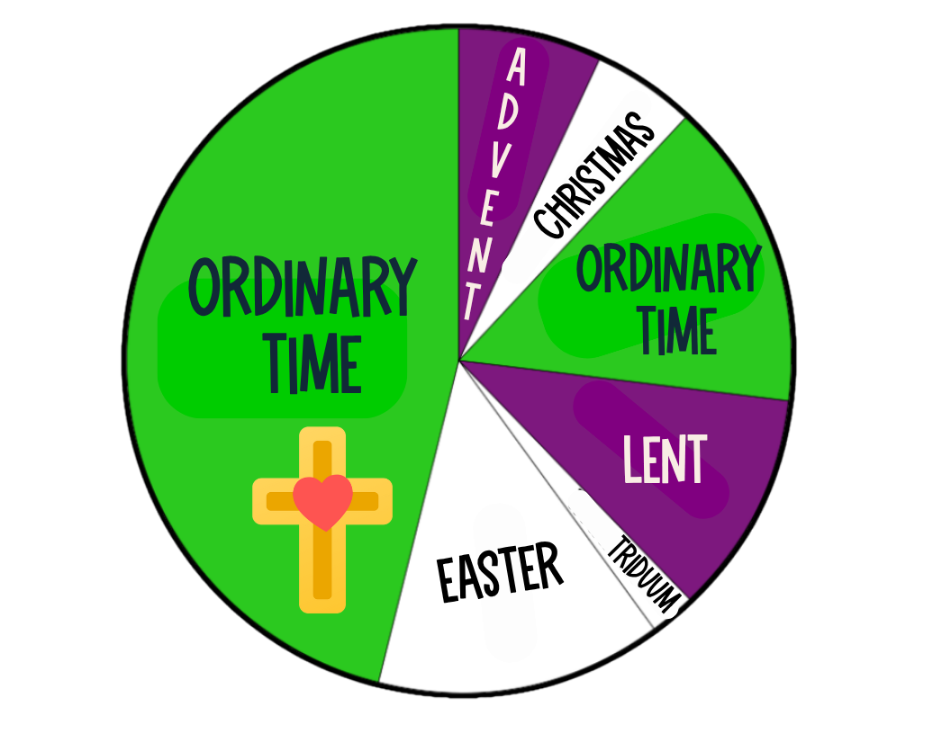
Ordinary Time (in Latin: Tempus per annum) is the part of the liturgical year in the liturgy of the Roman Rite, which falls outside the two great seasons of Christmastide and Eastertide, or their respective preparatory seasons of Advent and Lent.
It begins on Monday after the Sunday following January 6 and continues until Tuesday before Ash Wednesday.
18th/1/26 – 2nd Sunday Ordinary Time, Yr A–Missal P.81

MASS INTENTIONS are needed URGENTLY please, FOR WEEKDAY MASSES!
Please take a Parish envelope in the back of the Church, fill the form and bring it back ASAP if you would like to offer a Mass.
Parish Collection Sunday 4/1
Gift Aid: £307.15 + Loose Plate: £393.40 = Total: £700.55
NO CASH is kept on Church premises!
Thank you for your generosity and continual support.

We need your help, if possible, please!
We are hoping for our parishioners to help us with £3 or MORE (only if you can afford it) each week for the offertory collection during Masses.
This will truly help us greatly especially with parish repairs, projects, children’s activities and parties. Thanks in advance for your kindness and generosity.

***We are in the process of acquiring livestreaming services through our YouTube Channel.
This ministry is specially for the sick and housebound, we appreciate any support.
Thanks! Blessings! ***

We continuously PRAY for those Parishioners who are sick and housebound. Please email the Parish Office with names of those in need of prayers.

